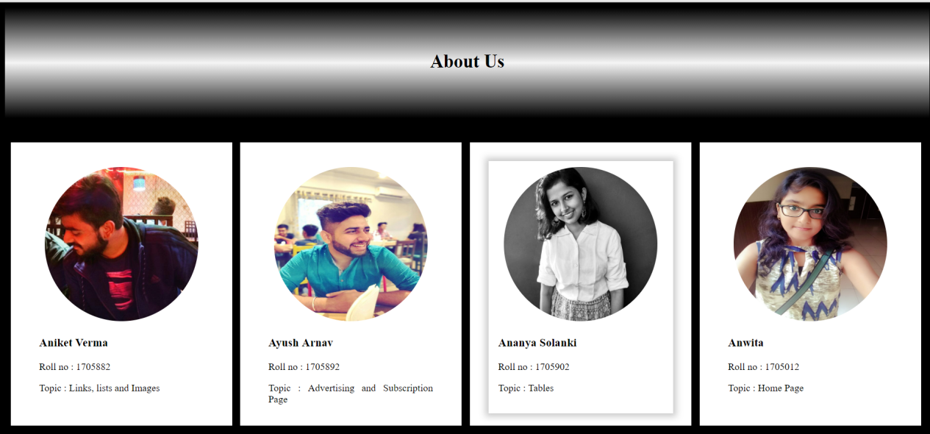

HOVER EFFECT BY CARD-INNER WHEN HOVERING OCCURS OVER CARD.

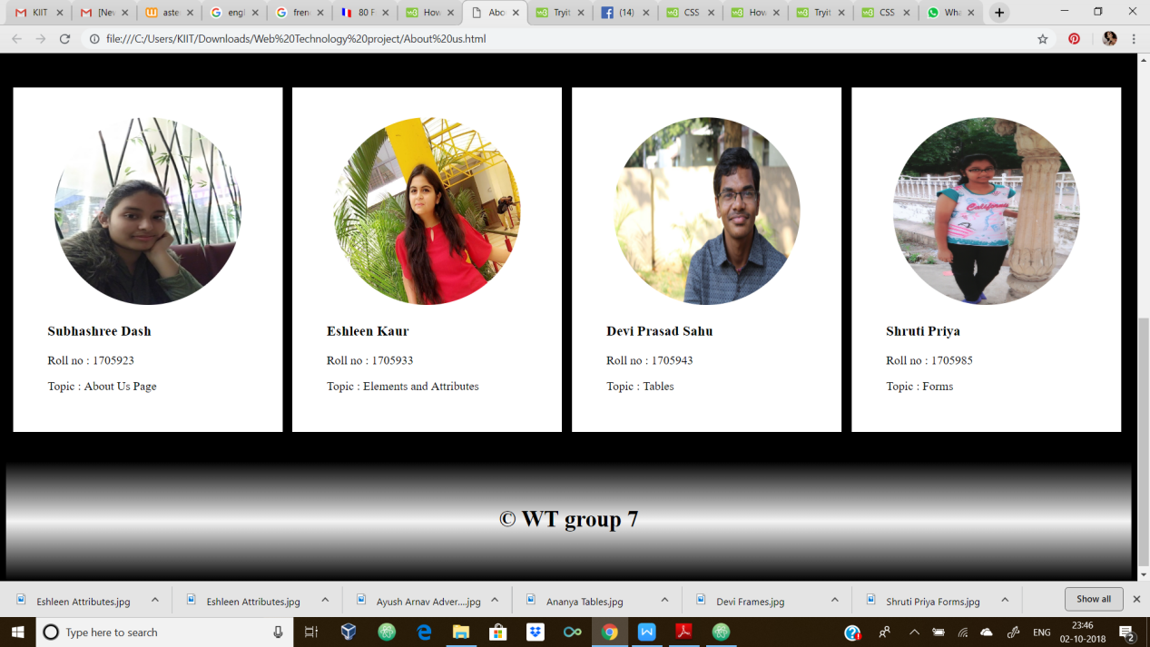

The web page is divided into many divisions. Most of the divisions have classes in them. The classes in the file would be:

* titlebar : It styles the heading “About Us ”.
* card : It makes the card.
* card-inner : It displays box-shadow upon hovering.
* container : It contains the written part of each card.
* row : It is made to contain the cards in one row.
* column : Each card acts as one column. Class card is under class column.
* padding : This class is made to create space between row and title bar.
* end : This division is at the end of the page with the copyright logo and the group name in it.

There is only one id in this entire file namely col which gives the background-color of the body.

The titlebar and end simply specify the height, width, background-image,padding, and text-align,font-size and font-weight.

The card is made by specifying height,width,background-color, padding and text-align. It has two parts :-- image and another division containing class container. The container contains the details of the images as given in each of the cards.

There are 4 cards in a row. This is ensured by the classes row and column. There are two rows, each row has 4 columns. Within a class row there are 4 sub-classes columns. Each class column has a class card. The row is displayed as a table and the columns as table-cells.

The card has another division card-inner. When we hover on the card, card inner displays a box-shadow as shown ABOVE.